Naam: Datum:

Unplugged

**Programmeer-estafette**

Estafette-afbeeldingen

Estafette-afbeelding 1

|  |  |  |  |
| --- | --- | --- | --- |
|  |  |  |  |
|  |  |  |  |
|  |  |  |  |
|  |  |  |  |

Estafette-afbeelding 2

|  |  |  |  |
| --- | --- | --- | --- |
|  |  |  |  |
|  |  |  |  |
|  |  |  |  |
|  |  |  |  |

Revisie 141119.1a

U

**Programmeer-estafette**

Estafette-afbeeldingen

|  |  |  |  |
| --- | --- | --- | --- |
|  |  |  |  |
| Estafette-afbeelding 3 |  |  |  |
|  |  |  |  |
|  |  |  |  |

Estafette-afbeelding 4

|  |  |  |  |
| --- | --- | --- | --- |
|  |  |  |  |
|  |  |  |  |
|  |  |  |  |
|  |  |  |  |

Revisie 141119.1a

U

**Programmeer-estafette**

Estafette-afbeeldingen

Estafette-afbeelding 5

|  |  |  |  |
| --- | --- | --- | --- |
|  |  |  |  |
|  |  |  |  |
|  |  |  |  |
|  |  |  |  |

Estafette-afbeelding 6

|  |  |  |  |
| --- | --- | --- | --- |
|  |  |  |  |
|  |  |  |  |
|  |  |  |  |
|  |  |  |  |

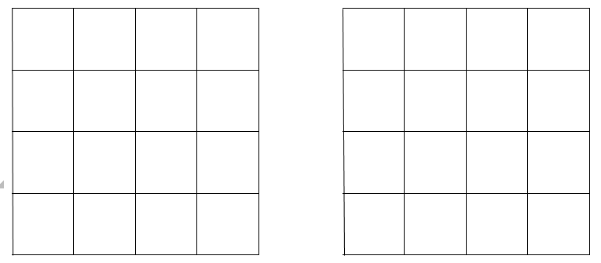

U

**Programmeer-estafette**

Estafette-afbeeldingen

# 



U

**Programmeer-estafette**

Estafette-afbeeldingen